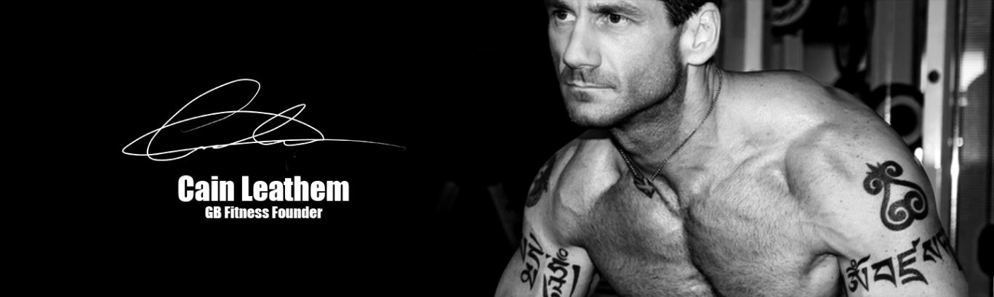
Workout on the Road…

CHEST
Press Ups:
Keeping the body alignment straight and face down completely lower the body to the floor and press back up with arms. Hands should be at shoulder width and under the shoulder point with elbows held wide. Level one can be carried out with the knees on the ground. Once you can complete 15 repetitions try with the knees off the floor, with the hands and the feet contacting with the ground (i.e. a full press up). Keep the head in a straight position and looking at the floor throughout.
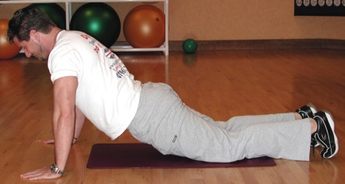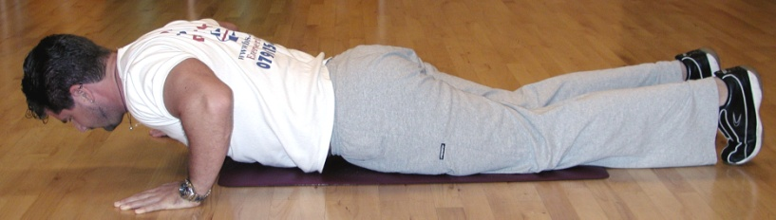

BACK
Bent Over Rows:
Standing with feet shoulder width and the knees slightly bent. Bend over at the waist with the bum out and pushed up to dip the lower back in. Pull the shoulders back to hold the chest high and keep head in line with the spine. Holding the theraband tightly pull back bringing the elbows close to the sides and beyond the back at waist level. Relax arms back straight, keeping them under control so as not to pull the shoulder.
LEGS AND BUTT
Resisted Squats:
Stand with feet on the theraband at shoulder width and the band held tight at the lower position. This is a squat down stance with the knees bent and held over the toes, with the bum held low as if sitting. Stand up into a full upright position. Squat back down with the knees out and the bum down low and repeat.
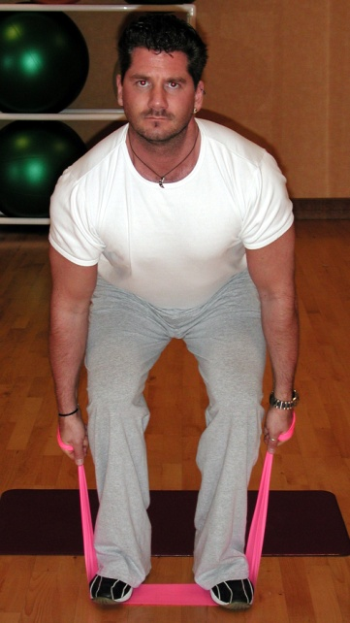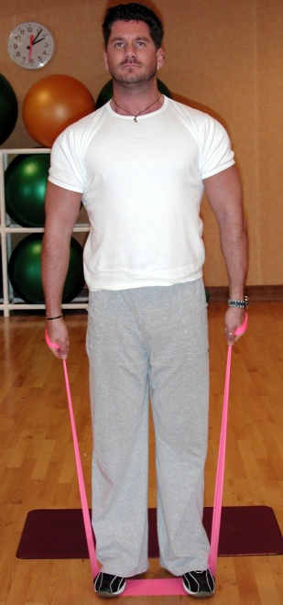

SHOULDERS
Standing Resisted Upright Row:
Stand on the band with the feet at shoulder width. With the arms straight and to the front of the hips tighten the theraband to give tension. Raise the elbows up high, keeping the hands down at a lower point, with the forearms relaxed. Slowly straighten arms back to straight position and repeat.
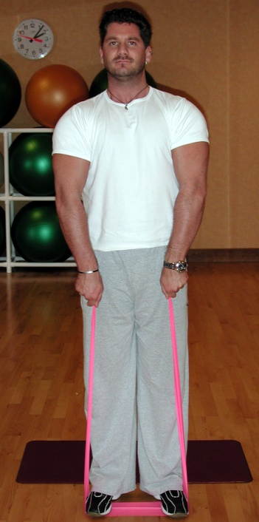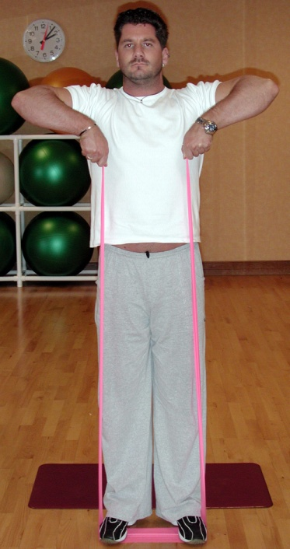
ARMS (front)
Standing Bicep Curl:
Stand on the band with the feet at shoulder width. With the arms straight and to the sides of the hips tighten the theraband to give tension. Bend both arms at the elbow to flex the arm up so that the fist comes towards the shoulder. Let the arms return to straight under control.
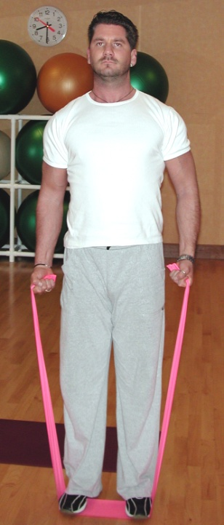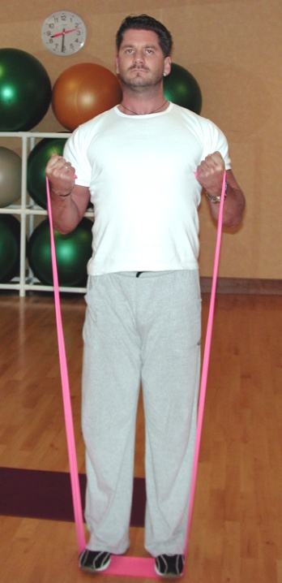

ARMS (rear)
Standing Alternate Overhead Arm Extension:
Stand with one foot on one end of the theraband and grab it with the other hand, with the arm bent back overhead, elbow up and there is good tension in the band. Keeping the body straight extend the arm straight overhead. Slowly lower back to the start position and repeat.
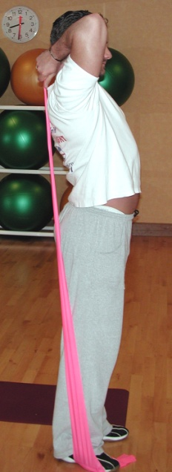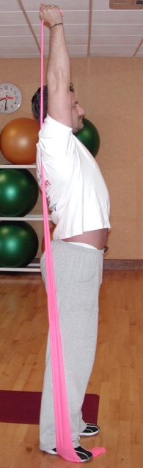

ABS
Abdominal Crunch:
Lie with your back on the floor and knees bent at 90 degrees. Keeping the head back in line with the spine (keeping a view of the ceiling) slowly raise the shoulders off the floor and crunch down so that the abdominal muscles shorten the distance between the chest and the groin. Slowly lower back down to the floor.
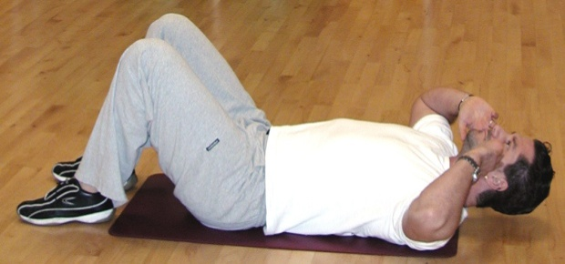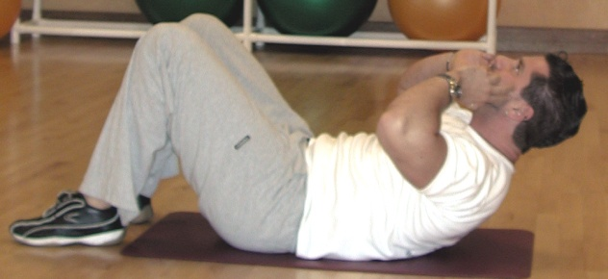

* Carry out 15 repetitions of each exercise in turn with no rest in between exercises. Work each rep as a 2 second up, pause and 2 second down count. When you have done 15 reps of each exercise in turn rest for 1 minute and then repeat in order.

At the end of this routine would be a good time to carry out your floor stretches as directed to aid flexibility and relax the worked muscles.

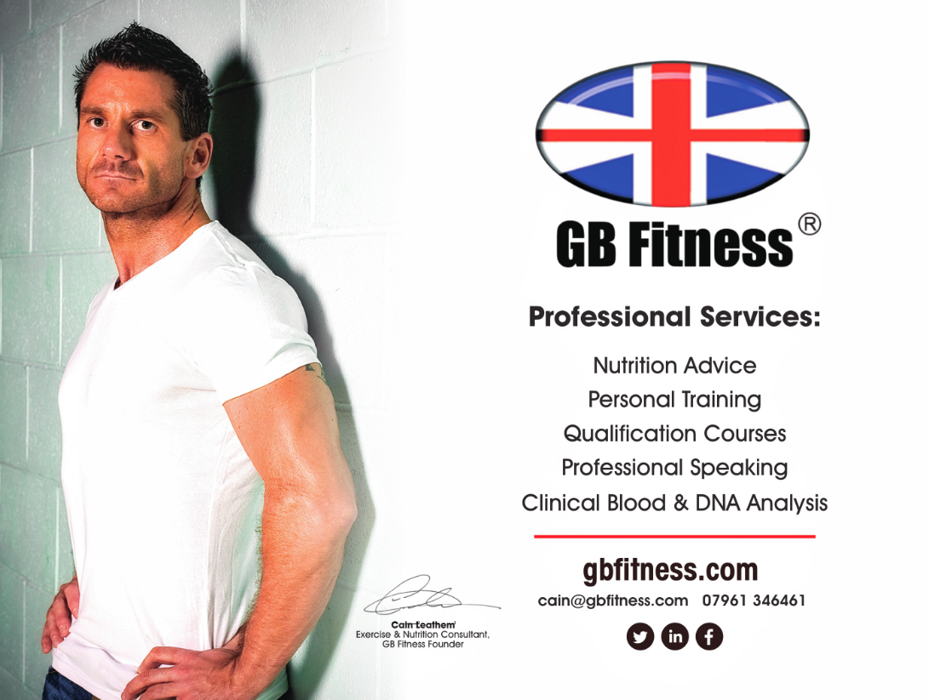

These instructions are provided for clients of Cain Leathem that have been personally
instructed on the techniques of these exercises.
At this time I am happy to share but please be careful and do not get hurt. Take it easy and repeat each day.

